JWTD Assignment 7.1

Name: Siddhi Shenoy

Roll No: 231047018

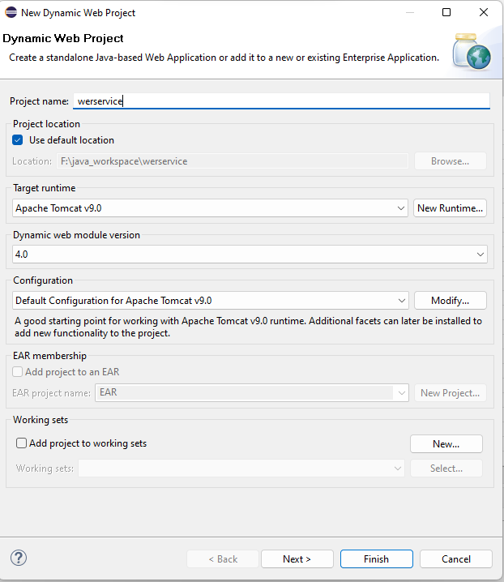

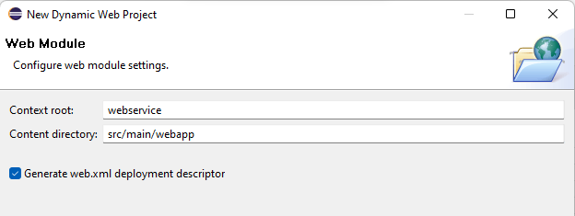

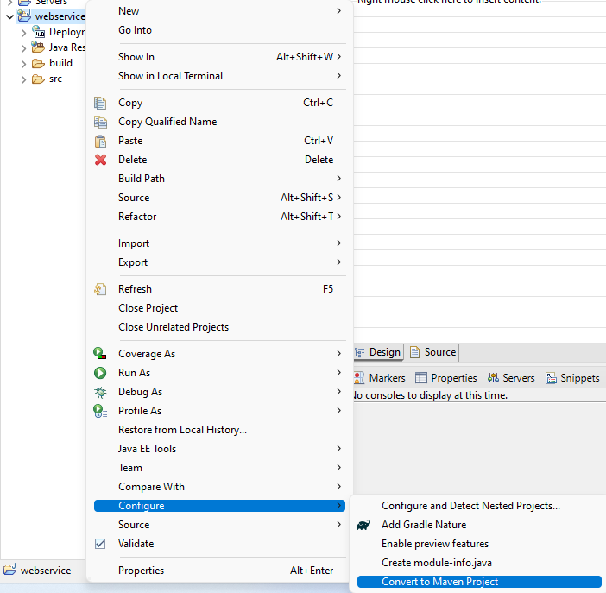

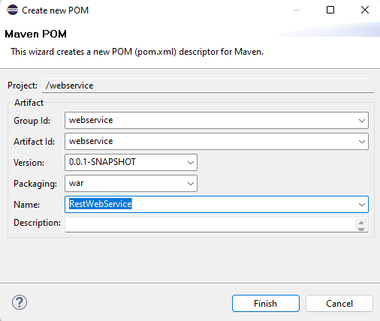

Content of the pom.xml file should be:

<project xmlns="http://maven.apache.org/POM/4.0.0" xmlns:xsi="http://www.w3.org/2001/XMLSchema-instance" xsi:schemaLocation="http://maven.apache.org/POM/4.0.0 <https://maven.apache.org/xsd/maven-4.0.0.xsd>">

<modelVersion>4.0.0</modelVersion>

<groupId>webservice</groupId>

<artifactId>webservice</artifactId>

<version>0.0.1-SNAPSHOT</version>

<packaging>war</packaging>

<name>RestWebService</name>

<build>

<plugins>

<plugin>

<artifactId>maven-compiler-plugin</artifactId>

<version>3.8.1</version>

<configuration>

<release>17</release>

</configuration>

</plugin>

<plugin>

<artifactId>maven-war-plugin</artifactId>

<version>3.2.3</version>

</plugin>

</plugins>

</build>

<dependencies>

<dependency>

<groupId>org.glassfish.jersey.containers</groupId>

<artifactId>jersey-container-servlet</artifactId>

<version>2.39.1</version>

</dependency>

<dependency>

<groupId>com.googlecode.json-simple</groupId>

<artifactId>json-simple</artifactId>

<version>1.1.1</version>

</dependency>

<!-- <https://mvnrepository.com/artifact/com.microsoft.sqlserver/mssql-jdbc> -->

<dependency>

<groupId>com.microsoft.sqlserver</groupId>

<artifactId>mssql-jdbc</artifactId>

<version>12.6.1.jre11</version>

</dependency>

<dependency>

<groupId>org.glassfish.jersey.inject</groupId>

<artifactId>jersey-hk2</artifactId>

<version>2.39.1</version>

</dependency>

</dependencies>

</project>

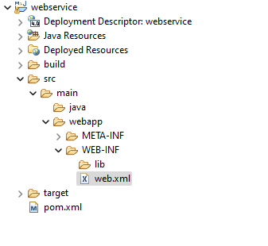

Content of the web.xml file should be:

<?xml version="1.0" encoding="UTF-8"?>

<web-app xmlns:xsi="http://www.w3.org/2001/XMLSchema-instance" xmlns="http://xmlns.jcp.org/xml/ns/javaee" xsi:schemaLocation="http://xmlns.jcp.org/xml/ns/javaee <http://xmlns.jcp.org/xml/ns/javaee/web-app_4_0.xsd>" id="WebApp_ID" version="4.0">

<display-name>webservice</display-name>

<welcome-file-list>

<welcome-file>index.html</welcome-file>

<welcome-file>index.jsp</welcome-file>

<welcome-file>index.htm</welcome-file>

<welcome-file>default.html</welcome-file>

<welcome-file>default.jsp</welcome-file>

<welcome-file>default.htm</welcome-file>

</welcome-file-list>

<servlet>

<servlet-name>Jersey REST Service</servlet-name>

<servlet-class>org.glassfish.jersey.servlet.ServletContainer</servlet-class>

<init-param>

<param-name>jersey.config.server.provider.packages</param-name>

<param-value>com.webService</param-value>

</init-param>

<load-on-startup>1</load-on-startup>

</servlet>

<servlet-mapping>

<servlet-name>Jersey REST Service</servlet-name>

<url-pattern>/rest/*</url-pattern>

</servlet-mapping>

</web-app>

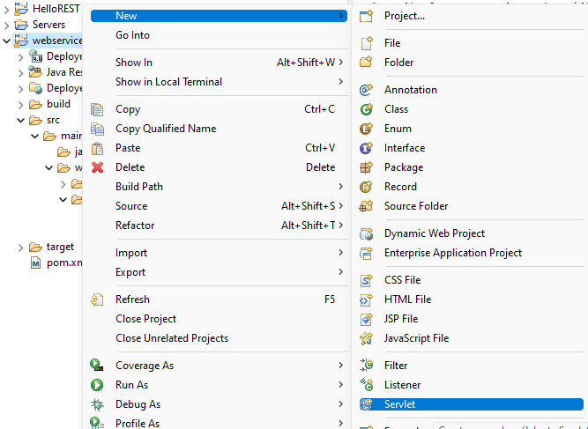

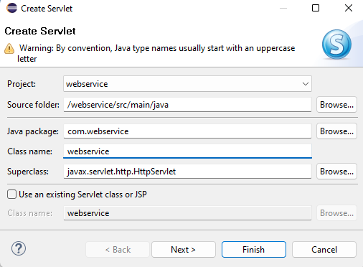

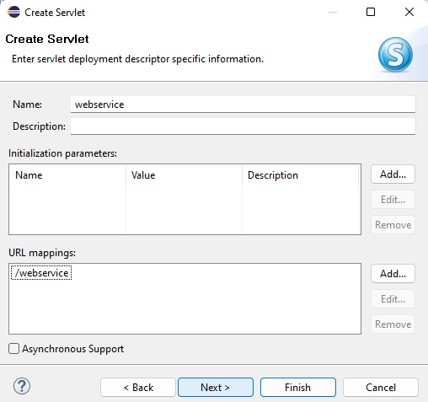

Content of webservice.java should be:

**package** com.webservice;

**import** java.io.PrintWriter;

**import** java.sql.Connection;

**import** java.sql.DriverManager;

**import** java.sql.PreparedStatement;

**import** java.sql.ResultSet;

**import** java.sql.SQLException;

**import** javax.ws.rs.FormParam;

**import** javax.ws.rs.GET;

**import** javax.ws.rs.POST;

**import** javax.ws.rs.Path;

**import** javax.ws.rs.PathParam;

**import** javax.ws.rs.Produces;

**import** javax.ws.rs.core.MediaType;

**import** org.json.simple.JSONObject;

@Path("/bonjour")

**public** **class** webservice {

@GET

@Path("/TestJSON")

@Produces(MediaType.***APPLICATION_JSON***)

**public** String TestJSON() {

JSONObject obj = **new** JSONObject();

obj.put("name", "User1");

obj.put("num", **new** ~~Integer~~(100));

obj.put("var1", 1004);

obj.put("balance", **new** ~~Double~~(1000.21));

obj.put("is_vip", **new** ~~Boolean~~(**true**));

**return** obj.toJSONString();

}

@POST

@Produces(MediaType.***TEXT_HTML***)

**public** String direBonjour1(

@FormParam("param1") String param1,

@FormParam("param2") **int** param2) {

// Use the received parameters in your logic

**return** "POST method! param1=" + param1 + ", param2=" + param2;

}

@GET

@Path("/{param1}/{param2}")

@Produces(MediaType.***TEXT_HTML***)

**public** String sayJsonHello( @PathParam("param1") String param1,

@PathParam("param2") **int** param2) {

// return "{\"name\":\"greeting\", \"message\":\"Bonjour tout le monde!\"}";

**return** "<html><body><h1>"+param1 + "Connected<h1></body></html>";

}

}

Download and install postman:

